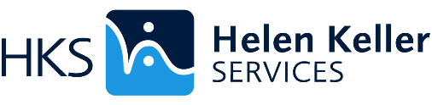

# NDEAM Webinar Celebrating Accomplishments and Building an Inclusive Tomorrow: Increasing Access & Equity for Individuals who are blind and DeafBlind

### **Date** October 4, 2023 from 2-3:30pm EDT

### **Presenters**

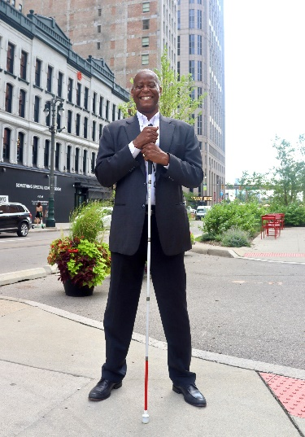

**Gary Horton**, President of Vanward Consulting Services, LLC

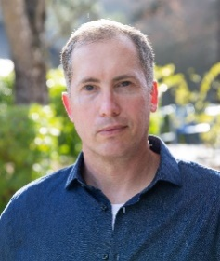

**Darryl Adams,** Director of Accessibility with Intel

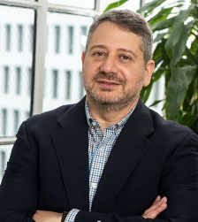

**Joe Devon,** Head of Accessibility, AI Futurist at Formula Monks

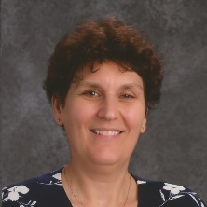

**Dr. Sara Coleman,** Owner of SB Coleman Consulting, LLC

### Summary

Our annual NDEAM Webinar highlights accessibility in the workplace, success stories, a panel discussion with industry leaders, some who have lived experience with dual sensory loss, and a Q&A session.

## Register

Sign up for the webinar at <https://www.helenkeller.org/NDEAM2023>